**TABLE OF CONTENTS**

1. **ABSTRACT**
2. **INTRODUCTION**
3. **BENEFITS OF IMPLEMENTATION**
4. **REQUIREMENT SPECIFICATION**

* **HARDWARE REQUIREMENTS**
* **SOFTWARE REQUIREMENTS**

1. **SCHEMA STRUCTURE**

* **FRONTEND STRUCTURE**
* **BACKEND STRUCTURE**
* **SQL STRUCTURE**

**ABSTRACT**

The employee management System (EMS) stands at the forefront of modern HR solutions, integrating HTML, CSS, JavaScript, Java, Spring Boot, and React to create a comprehensive and efficient platform. With a focus on user-centric design, the EMS ensures a seamless experience for administrators, Managers, and employees, incorporating robust security measures such as user authentication and role-based access control. The system’s modules cover a wide array of HR functions, including employee information management, leave tracking, attendance recording, task/projects assignment, performance evaluation, and payroll /benefits administration. React powers the frontend, delivering a responsive and dynamic user interface that facilitates smooth navigation and interaction. On the backend, Java and Spring Boot provides a solid foundation for secure data handling, ensuring the confidentiality and integrity of sensitive HR information. Real-time collaboration is a cornerstone of the EMS, fostering effective communication and streamlined processes with the organization. The system’s goal is to optimize HR workflows, contributing to increased organizational productivity and heightened employee satisfaction. By utilizing a cutting-edge tech stack, the EMS offers a scalable, secure, and efficient solution for managing the complexities of human resource management in the fast-paced and dynamic landscape of the modern workplace.

**INTRODUCTION**

In the Dynamic realm of contemporary business, efficient management of human resources is pivotal of organizational success. The Employee Management System (EMS), powered by a sophisticated integration of HTML, CSS, JS, and Java within the React framework, emerges as a transformative solution to address the intricate challenges of workforce administration.

Welcome to a comprehensive system designed to revolutionize the way businesses handle their personnel. The EMS is a unified platform that seamlessly combines attendance tracking, performance evaluation, payroll management, and robust communication tools. Its purpose is clear which is to simplify, optimize, and elevate the management of diverse and dynamic workforce.

As we navigate the complexities of modern business, the EMS stands at the forefront, offering a user-friendly interface that empowers organizations to streamline processes and enhance overall operational efficiency. From accurate attendance tracking leveraging advanced technologies to transparent performance assessments through data-driven metrices, the EMS ensures a fair and objective approach to workforce management.

In the world where time is of the essence, the system automates routine tasks, freeing up valuable resources for strategic initiatives. Imagine a workspace where payroll processes are error-free communication flows seamlessly across teams. The EMS not only envisions this nut brings it to life, contributing to higher levels of employee satisfaction and fostering a positive work environment.

As we embark on this journey of digital transformation, the EMS is not just a tool; It’s a paradigm shift. Its integration of Java and React not only ensures scalability and robustness but also positions the system at the forefront of technological advancements.

**Problem Statement:**

Organizations often face challenges in efficiency management and overseeing their workforce, leading to issues such as ineffective communication, resources misallocations, and difficulty in tracking employee performance. The absence of a centralized and streamlined Employee Management System results in a lack of real-time data access, making it cumbersome for HR departments to handle employee records, monitor attendance, track skill development, and ensure compliance with organization. Therefore, there is a critical need for the development and implementation of a comprehensive Employee Management System that addresses these challenges, facilitating seamless communication, efficient resource allocation, and comprehensive employee performance monitoring, ultimately contributing to the overall success and sustainability of the organization.

**Benefits of implementing Employee management system:**

1. **Enhanced Efficiency and Time Savings:**

One of the primary advantages of implementing an Employee Management System is the substantial improvement in efficiency and time savings. Traditional manual processes, such as paper-based attendance tracking and manual payroll calculations, are not only time consuming but also prone to errors. EMS automates these tasks, allowing employees to clock in and out digitally, automatically updating attendance records and expending the payroll process. This not only reduces the burden on HR personnel but also minimizes the chances of errors associated with manual data entry.

1. **Streamlined HR Processes:**

An Employee Management System acts as a central repository for all HR-related data, streamlining various processes from recruitment to retirement. It facilitates the seamless management of employee records, performance evaluations, training programs, and more. With a few clicks, HR professionals can access comprehensive employee profiles, track career progression, and identify training needs. This centralized approach enables organizations to make informed decisions, allocate

resources efficiently and foster a culture of continuous improvement.

1. **Improved Employee Engagement and Communication:**

Effective communication is the backbone of a thriving workplace. Employee Management Systems provide a platform for seamless communication between employees and management. Features such as internal messaging systems, collaborative tools, and document sharing enhance team collaboration, fostering a more connected and engaged workforce. Additionally, real-time feedback and performance evaluations can be conducted through the system, promoting a

transparent and constructive dialogue between employees and their supervisors.

1. **Compliance and security:**

Navigating the complex landscape of employment laws and regulations can be a daunting task. Employee Management Systems are designed to ensure compliance with labor laws, tax regulations, and industry-specific requirements. By automating processes such as tax calculations, leave management, and benefits administration,

organizations can significantly reduce the risk of non-compliance and associated penalties. Moreover, these systems often come equipped with robust security features, safeguarding sensitive employee, and ensuring confidentiality.

1. **Data-Driven Decision Making:**

In the age of big data, organizations are increasingly relying on data-driven insights to make informed decisions. Employee Management Systems provide valuable analytics and reporting tools that enable organizations to analyse workforce trends, identify performance patterns, and make strategic decisions based on real-time data. This empowers leaders to proactively address issues, optimize resource allocation, and align business strategies with workforce dynamics.

**Requirements Needed:**

An Employee Management System (EMS) is a crucial tool for the organizations to streamline HR processes and enhance workforce efficiently. To secure the successful implementation and functionality of an EMS, a comprehensive set of requirements must be identified and addressed. Here are the key requirements for an effective Employee Management System.

**Hardware Requirements:**

The most common set of requirements defined by any operating system or software application is the physical computer resources, also known as hardware. A hardware requirements list is often accompanied by a hardware compatibility list (HCL), especially in case of operating systems. An HCL lists tested, compatibility and sometimes incompatible hardware devices for a particular operating system or application. The following sub-sections discuss the various aspects of hardware requirements.

**Hardware Requirements for the present project:**

Processor: Intel i5 12th gen (8 cores 12 threads),

RAM: 8GB RAM,

Storage: 512GB Hard Disk

**SOFTWARE REQUIREMENTS:**

Software Requirements deal with defining software resource requirements and pre-requisites that need to be installed on a computer to provide optimal functioning of an application. These requirements or pre-requisites are generally not included in the software installation package and need to be installed separately before the software is installed.

**SOFTWARE REQUIREMENTS FOR PRESENT PROJECT:**

Operating System: Windows 11

**LANUAGES USED FOR THE PRESENT PROJECT:**

FRONTEND LANGUAGES: HTML, CSS, JavaScript, React.

DATABASE: MySQL

BACKEND LANGUAGES: Java, Spring boot (for connectivity)

**SCHEMA:**

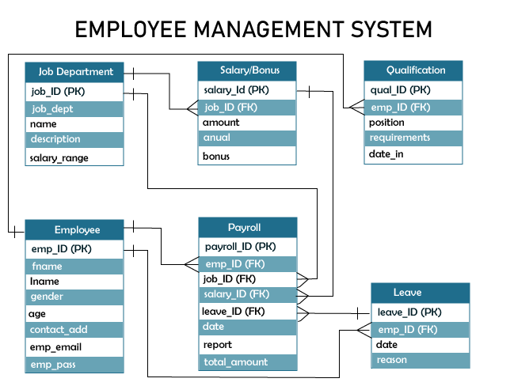

**Conclusion:**

The adoption of an Employee Management System is a strategic investment that yields multifaceted benefits for organizations. From enhancing efficiency and streamlining HR processes to fostering employee engagement and ensuring compliance, the advantages are manifold. As businesses evolve in the digital era, leveraging technology to manage and optimize the workforce has become imperative. The Employee Management System stands as a testament to the transformative power of technology in creating more agile, efficient, and employee-centric or organizations.